Smart Campus 2026
Report — Version 0
Digital campus services platform (Angular frontend, Spring Boot backend to come)
Name(s):Oussama, Youssef, Rayen, Ahmed Group: DSI33 Date: 10/10/2026

1. Introduction
Smart Campus 2026 is a digital campus services platform for students and administrators. This first phase delivers an Angular frontend using mock data; a Spring Boot backend will be connected later. All data is fictional and does not represent a real institution.

2. Objectives
- Provide one coherent, modern and responsive application for campus services.
- Offer two experiences: Student and Administrator (demo role switching, no real security).
- Prepare a clean architecture so mock services can later be replaced by REST APIs.

3. Scope
Included: demo login, dashboard, rooms, reservations, events, announcements, transport, cafeteria, lost & found, notifications, profile, and admin pages (overview, rooms, events, announcements, users).
Excluded: backend, real authentication, AI features or chatbot, PHP.

4. Actors
Student: consults and uses campus services (rooms, events, transport, etc.).
Administrator: has all student capabilities, plus management of rooms, events, announcements and users, and access to KPIs.

5. Functional requirements
- FR1 — Demo sign-in and role selection.
- FR2 — Personalized dashboard.
- FR3 — Room search and filtering.
- FR4 — Reservation creation, listing and cancellation.
- FR5 — Event browsing, registration and QR code placeholder.
- FR6 — Announcement feed with read/unread state and pinned items.
- FR7 — Transport timetable.
- FR8 — Cafeteria menus.
- FR9 — Lost & found search and reporting.
- FR10 — Notification management.
- FR11 — Profile editing.
- FR12 — Admin management of rooms, events, announcements and users; KPI charts.

6. Non-functional requirements
- Responsive design (desktop-first, tablet and phone).
- Accessibility: semantic HTML, keyboard navigation, sufficient contrast, chart summaries.
- Strict TypeScript without any.
- Lean dependencies and a maintainable feature-based structure.
- Builds and runs with ng serve / ng build without errors.

7. Technical choices
Angular (standalone components, Router, Signals, RxJS), TypeScript in strict mode, SCSS design system or Angular Material, and in-memory mock services (optional localStorage). Planned later: Spring Boot REST API.
Proposed structure: core (models, services, guards, interceptors), shared (components, pipes, ui), layout (shell, sidebar, topbar), features (one folder per module) and app.routes.ts.

8. Analysis

8.1 Use case diagram
The use case diagram shows two actors. The Administrator specializes the Student, so it inherits all student use cases and adds the management use cases. Every deletion includes a confirmation use case.
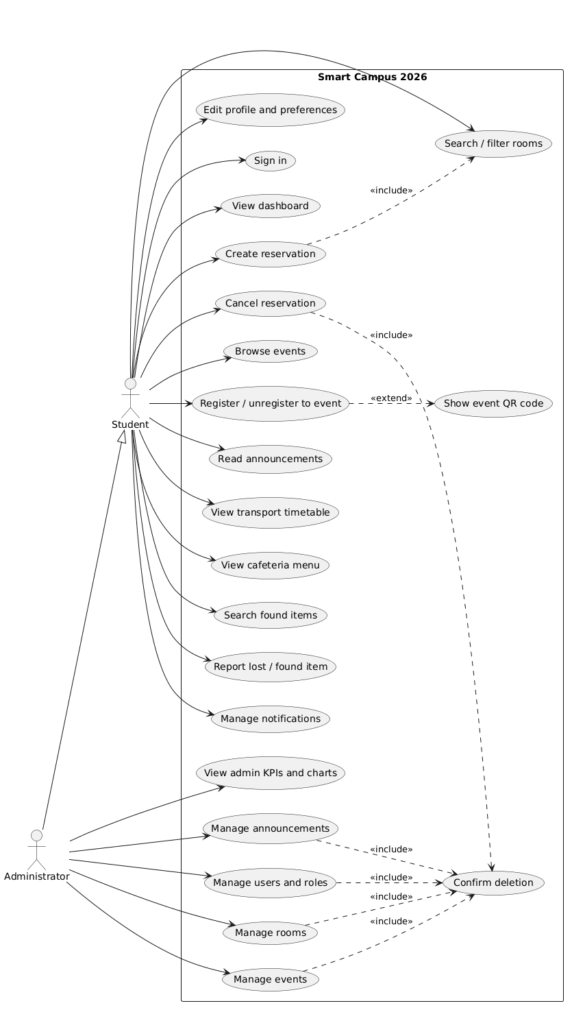
Figure 1: Use case diagram

8.2 Class diagram
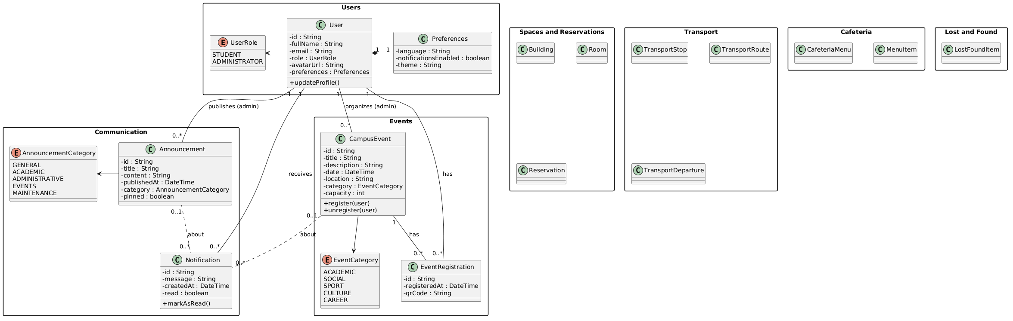
In this initial version, the class diagram details three packages: Users (User, Preferences, UserRole), Communication (Announcement, Notification, AnnouncementCategory) and Events (CampusEvent, EventRegistration, EventCategory). The packages Spaces and Reservations, Transport, Cafeteria, and Lost and Found are declared but will be completed in the next version.
Figure 2: Class diagram (V0)

9. Product backlog and planning
The product backlog is the prioritized list of everything to build. Version 0 contains the first four items, all in the Foundation epic and planned for Sprint 1 (21 story points).
ID | Epic | User story | Priority | Pts | Sprint | Status
PB-01 | Foundation | As a developer, I want design tokens, global SCSS and routing so the UI is consistent | Must | 3 | 1 | To Do
PB-02 | Foundation | As a user, I want an app shell (collapsible sidebar, top bar, mobile drawer) to navigate easily | Must | 8 | 1 | To Do
PB-03 | Foundation | As a developer, I want typed models and mock-data services so the app works without a backend | Must | 5 | 1 | To Do
PB-04 | Foundation | As a developer, I want reusable components (stat card, badge, empty state, dialog, page header) | Must | 5 | 1 | To Do
Table 1: Product backlog (V0, first 4 items)
Planned sprints: (1) foundation and app shell, (2) dashboard, rooms, reservations, events, (3) student services, (4) lost & found, profile, admin KPIs, (5) admin management and UX states, (6) accessibility, quality, documentation and integration guide.

10. Conclusion and next steps
Version 0 fixes the scope, the actors, the first part of the class diagram, the use cases and the initial backlog. Next steps: complete the remaining packages of the class diagram (V1), validate backlog priorities, start Sprint 1, and design the Spring Boot REST contract.

